15] DataFrame column operations

1) Download RAR on STAGING_AREA

2) Extract the RAR

3) Put the *.ipynb files in UBUNTU_HOME/test-jupyter/P3/M2/sm1

4) Import the notes in Jupyter Notebook

5) Follow the instructions and give the solutions

* Code/Dataset

data/1_DataFramecolumnoperations.rar

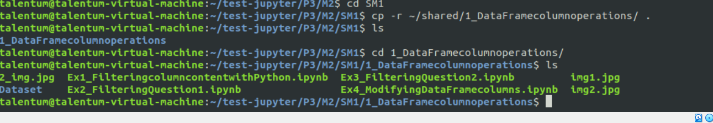

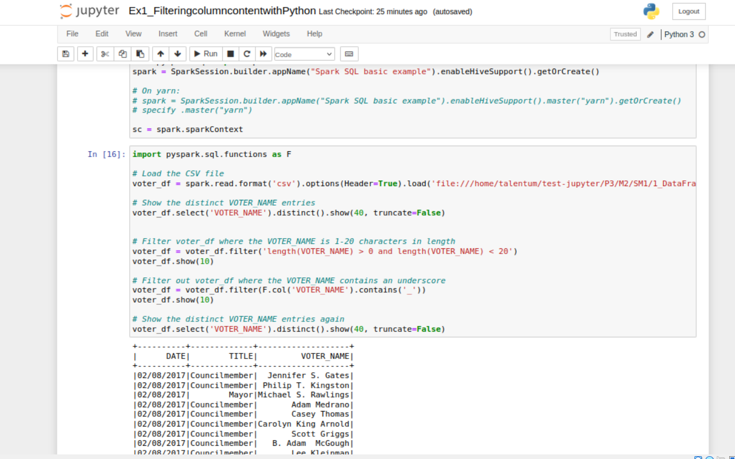

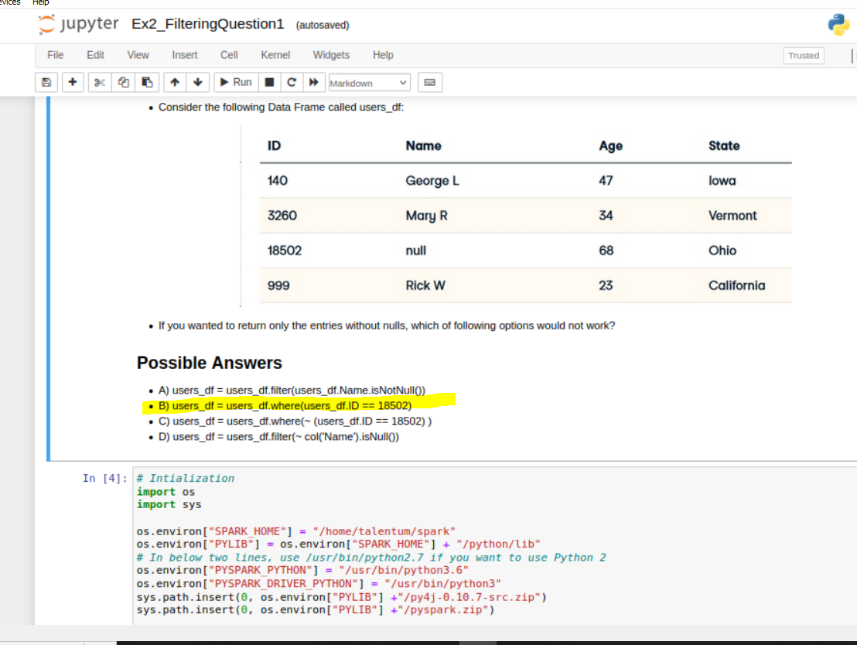

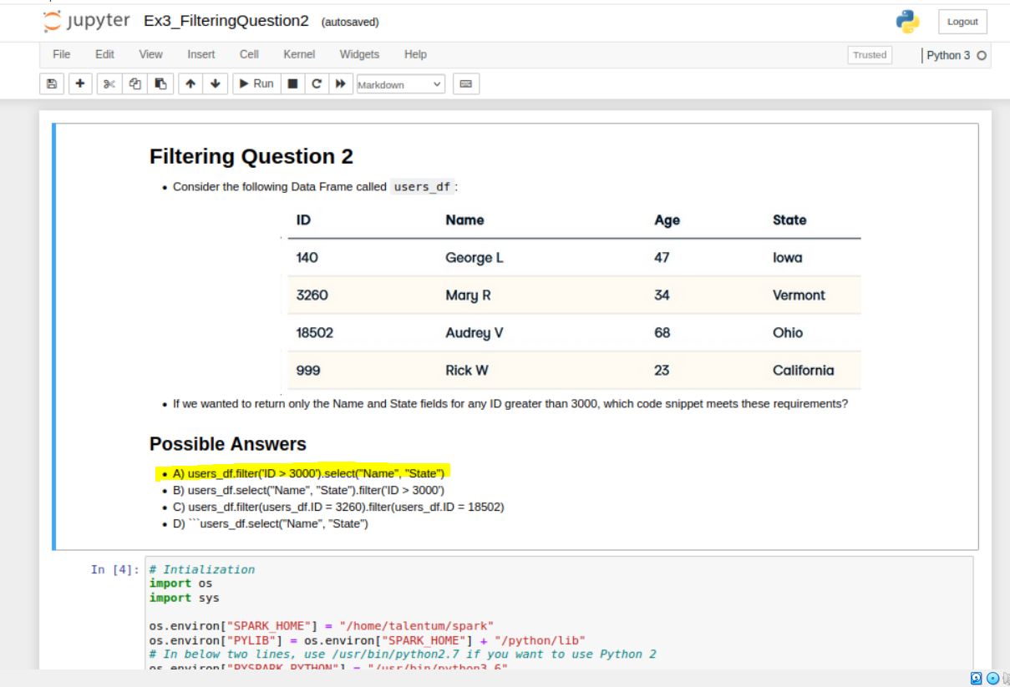

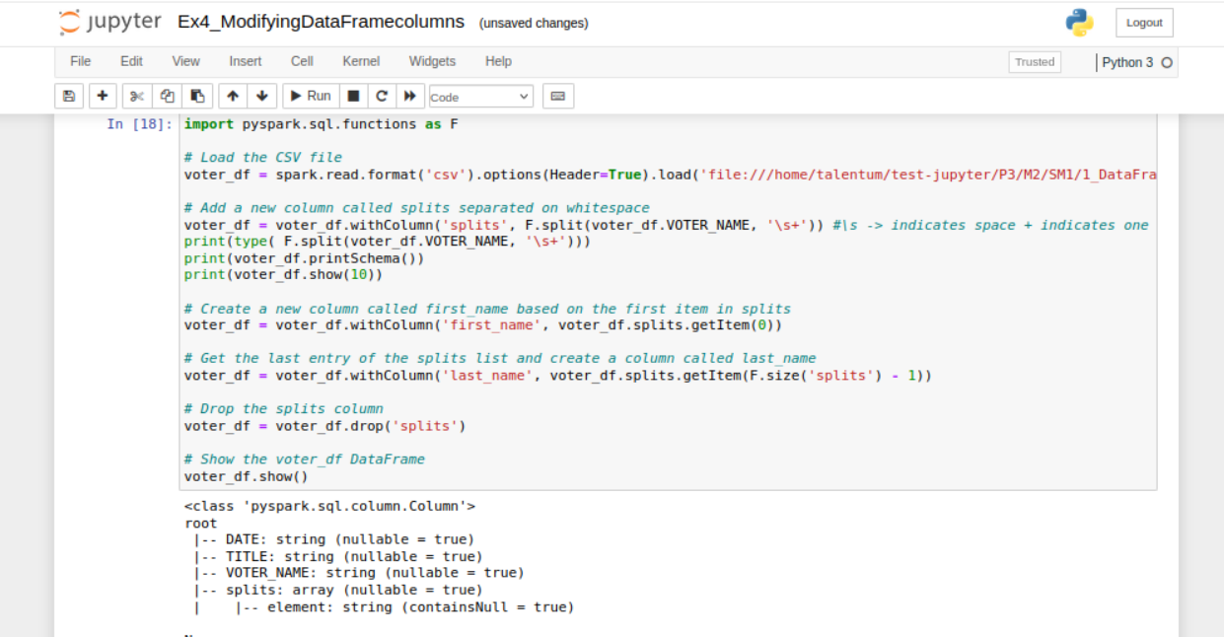

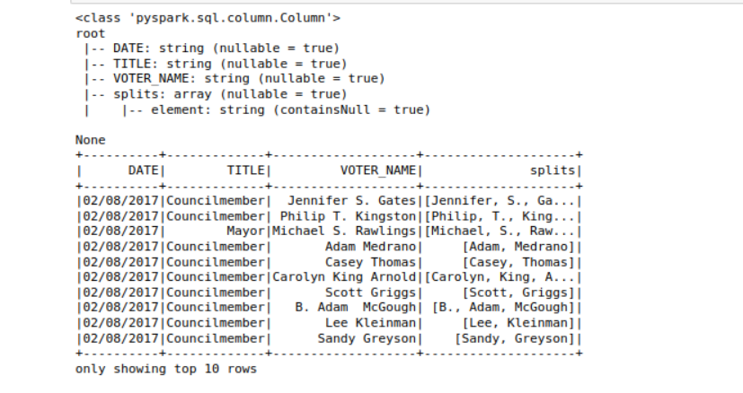

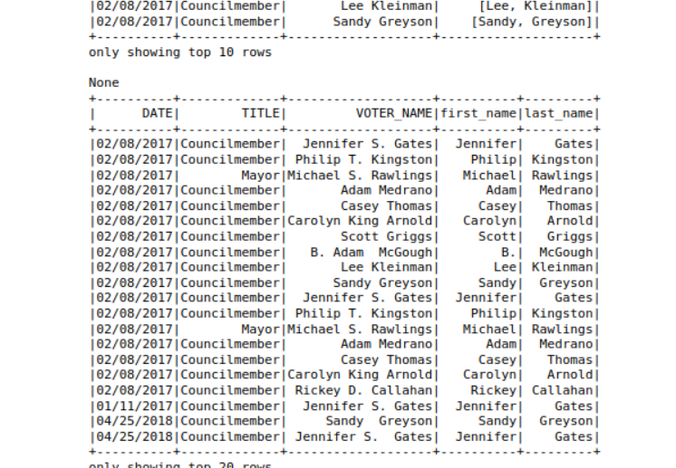

16] Conditional DataFrame column operations

P3->M2->sm21) Download RAR on STAGING_AREA

2) Extract the RAR

3) Put the *.ipynb files in UBUNTU_HOME/test-jupyter/P3/M2/sm2

4) Import the notes in Jupyter Notebook

5) Follow the instructions and give the solutions

* Code/Dataset

data/2_ConditionalDataFramecolumnoperations.rar

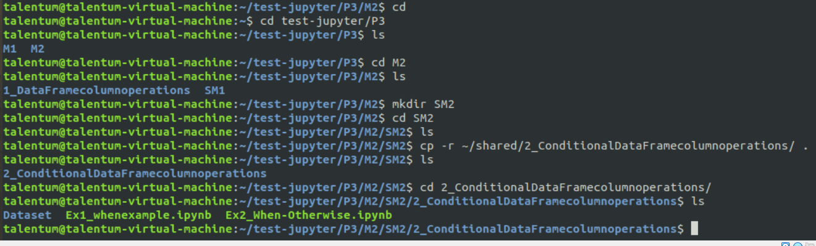

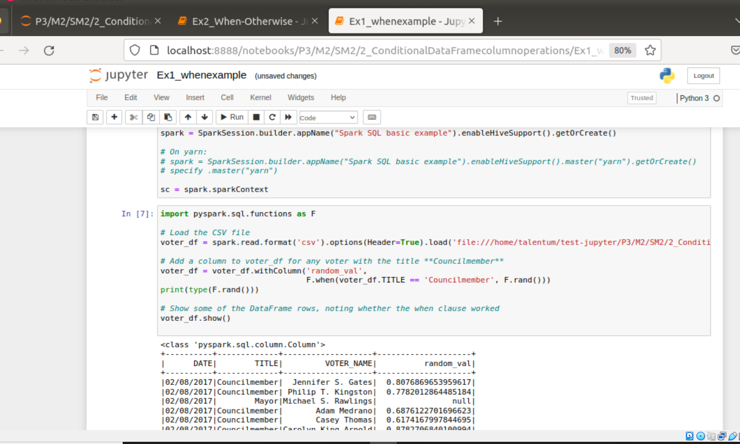

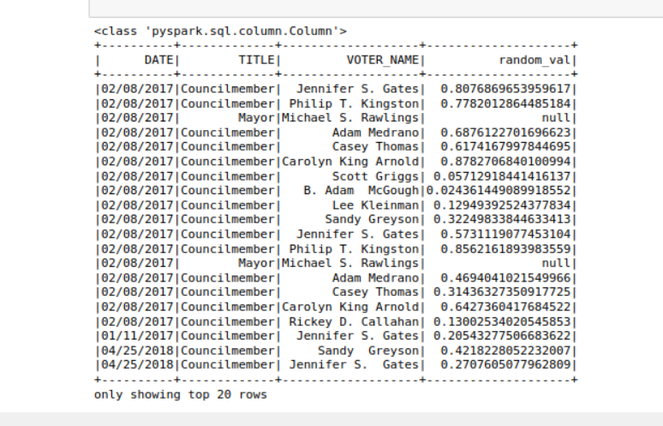

2)

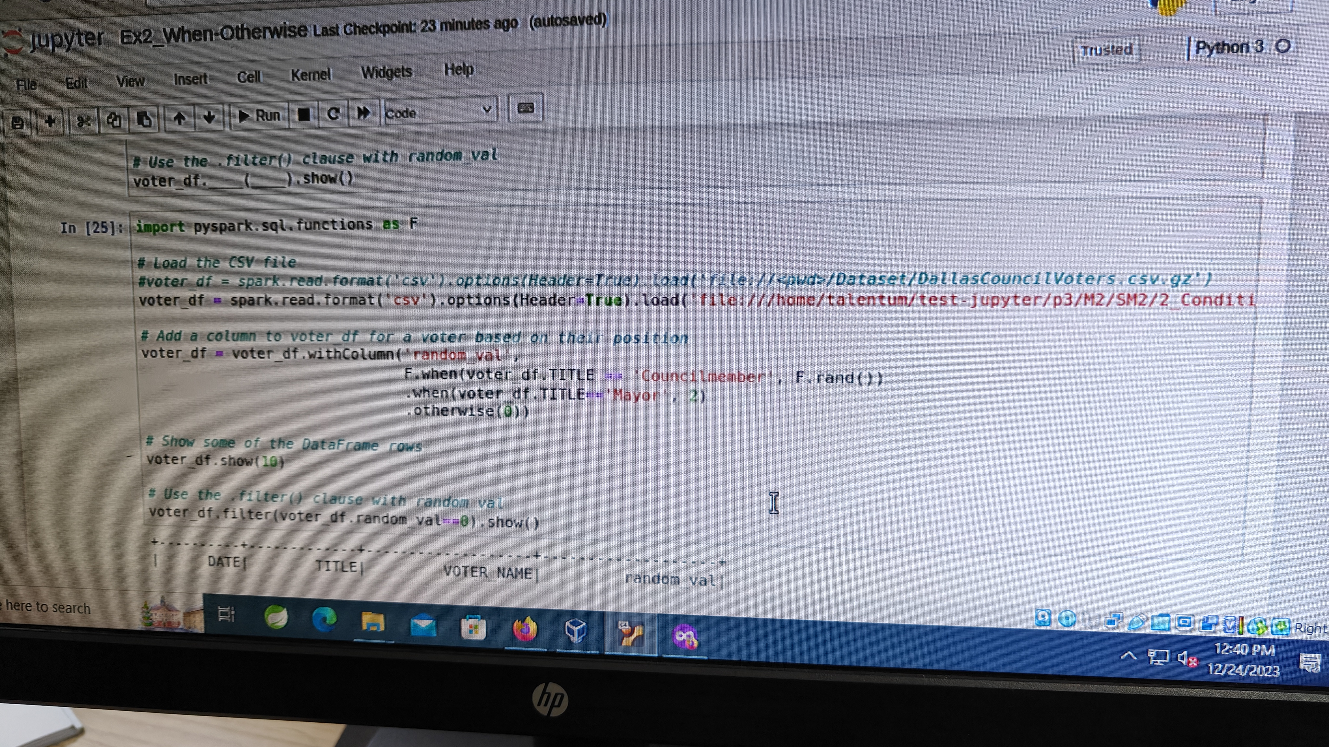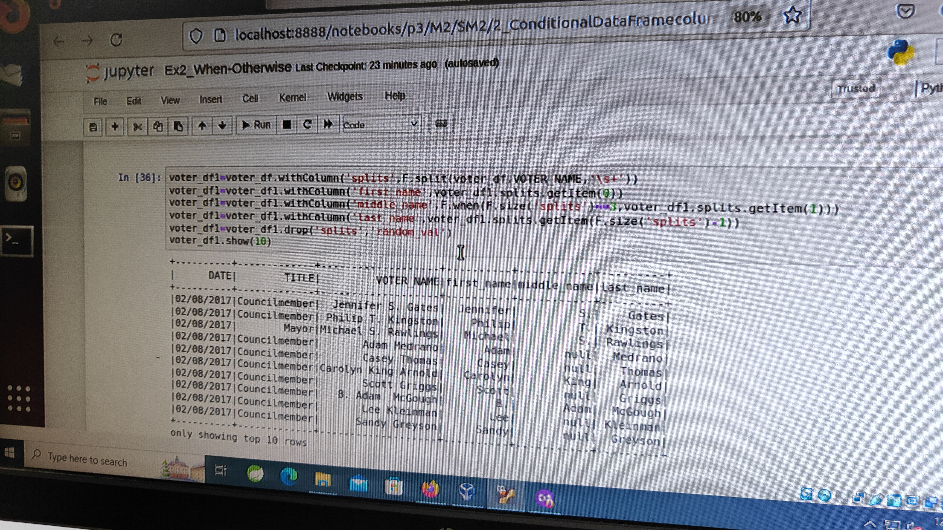

17] User defined functions

1) Download RAR on STAGING_AREA

2) Extract the RAR

3) Put the *.ipynb files in UBUNTU_HOME/test-jupyter/P3/M2/sm3

4) Import the notes in Jupyter Notebook

5) Follow the instructions and give the solutions

* Code/Dataset

data/3_UserDefinedFunctions.rar

TimeLine = 30 Mins

